

Debugging MPI.NET Programs in Visual Studio

Douglas Gregor
Open Systems Laboratory, Indiana University

Published: September 2008

Launching an MPI.NET Program in Visual Studio
Visual Studio 2008 provides an MPI Cluster Debugger that allows one to launch and debug MPI applications from within Visual Studio, with the application itself running either locally or on a cluster.

Prerequisites
To debug an MPI.NET application in Visual Studio, you will need:
- Microsoft Visual Studio 2008 (with Service Pack 1) or newer with support for Remote Debugging installed
- MPI.NET
- Microsoft’s HPC Pack 2008 SDK or Compute Cluster Pack SDK
- Optional: Allinea’s DDTLite for Visual Studio

Configuring the MPI Debugger
The MPI Cluster Debugger works for both native applications and managed MPI applications, but there are several extra steps required to debug managed MPI.NET applications:

- Build your MPI.NET application in Debug mode. In this document, we’ll use the DatatypesTest test program from the MPI.NET source code as an example.
- From the Visual Studio menu bar, select File→Open→Project/Solution. In the Open Project dialog box, find and select the .exe for your program.
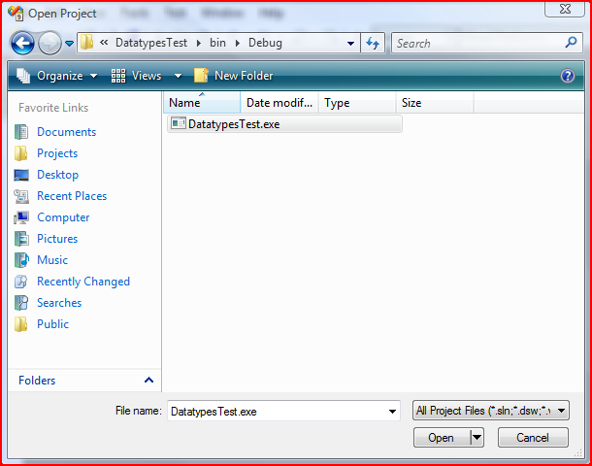
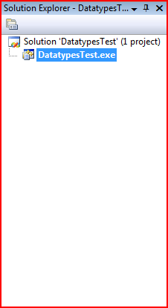
- Your new project will show up in the Solution Explorer. Right-click on the .exe file and select “Properties” to bring up the property page for this new project.

- In the property page, select the “Debugging” page under “Configuration Properties” and set the “Debugger to launch” combo box to the “MPI Cluster Debugger”. There are quite a few settings to change to configure the MPI debugger. They are:
  - MPIRun command: Set this to the full path to the mpiexec.exe program, which comes as part of the HPC Pack 2008 SDK or Compute Cluster Pack SDK.
  - MPIRun arguments: Any arguments you want to pass to mpiexec. In the screenshot below, we use “-n 2” to specify that we want to run two processes.
  - MPIRun Working Directory: The directory from which the application will be run.
  - Application Command: Full path to the application’s executable, including the name of the executable itself.
  - MPIShim Location: The location of the mpishim.exe program, which is part of Visual Studio’s Remote Debugger. In Visual Studio 2008, the location of this file is:
C:\Program Files\Microsoft Visual Studio 9.0\Common7\IDE\Remote Debugger\x86\mpishim.exe
  - Debugger Type: Set this to “Mixed”.
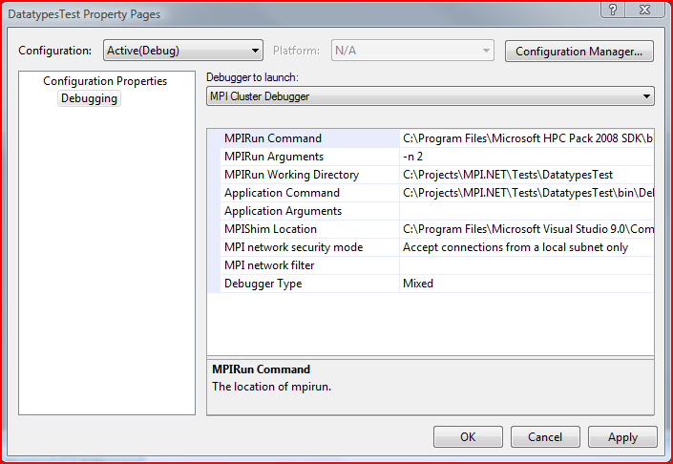

Debugging your Application
Once you have configured the MPI debugger, you can launch your MPI application under the debugger with F5 or from the menu. The document “Parallel Debugging Using Visual Studio 2005” has more information about the MPI debugger.

To add a breakpoint to your application, open up one of its source files and place a breakpoint in it. Then, all processes launched by the debugger will stop at that breakpoint. Typically, it’s best to put the breakpoint somewhere after the initialization of MPI (e.g., after the construction of the MPI.Environment object).

Many of Visual Studio’s debugging facilities work the same way in a parallel application as they do in non-parallel applications. The “Processes” debug window allows one to switch to any of the processes that are part of the MPI application.

For more advanced parallel debugging capabilities, Allinea’s DDTLite integrates with Microsoft Visual Studio 2008 to provide better inspection and debugging of MPI programs. Visit http://www.allinea.com for more information about DDTLite.

More Information and Downloads
MPI.NET homepage
http://www.osl.iu.edu/research/mpi.net/
MPI.NET reference documentation http://www.osl.iu.edu/research/mpi.net/documentation/reference/current/Index.html
MPI.NET mailing list
http://www.osl.iu.edu/mailman/listinfo.cgi/mpi.net
Allinea DDTLite
http://www.allinea.com/
Parallel Debugging Using Visual Studio 2005
http://www.microsoft.com/downloads/details.aspx?FamilyID=798b01f3-2bad-41c7-a34a-c2a6e6f9d535&displaylang=en

